⚠ IoT SAFETY SYSTEM ⚠
PROJECT REPORT
G.U.A.R.D
Gas Unit for Air Risk Detection
IoT-Based Automated Gas Leak Detection, Alert & Emergency Ventilation System

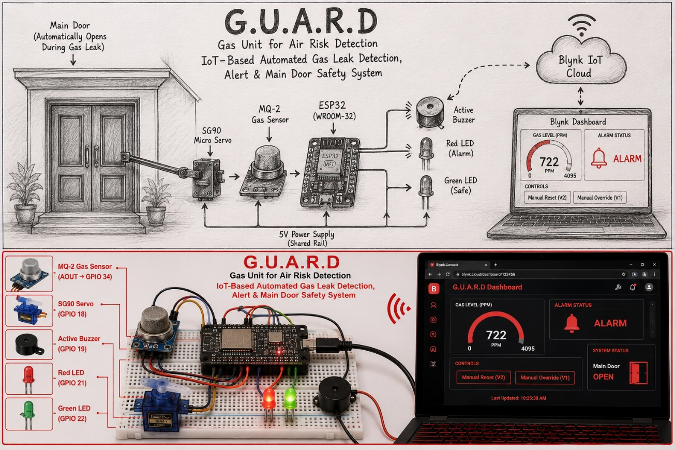

Prepared by
G. INDRANAG
B.Tech, Electronics and Communication Engineering

1. Abstract
G.U.A.R.D (Gas Unit for Air Risk Detection) is an IoT-enabled embedded safety system designed to autonomously detect combustible/toxic gas leaks and respond without requiring human intervention. Built around an ESP32 microcontroller, the system continuously samples an MQ-2 gas sensor and, upon crossing a calibrated threshold, triggers a multi-channel response: a visual alarm (red/green status LEDs), an audible double-beep buzzer pattern, and automatic actuation of a servo-driven emergency ventilation door. All events and live sensor data are synced to a Blynk IoT dashboard, giving the user real-time monitoring and two remote control actions — Manual Reset and Manual Override — from anywhere with an internet connection.
The system prioritizes fail-safe behaviour: once an alarm is cleared by the user via Manual Reset, the system intentionally locks out further automatic alarms until a full Manual Override is issued, preventing an unventilated space from silently re-arming itself. This report documents the hardware architecture, firmware logic, dashboard design, and operational testing of the system.

2. Objectives
- Continuously monitor ambient gas concentration using an MQ-2 sensor interfaced with the ESP32's ADC.
- Automatically trigger a visual and audible alarm when gas levels exceed a safe threshold.
- Automatically open an emergency ventilation door (servo-actuated) to assist air circulation during a leak event.
- Push real-time sensor data and alarm events to a cloud dashboard (Blynk) for remote visibility.
- Provide the user with two distinct remote controls — a Manual Reset (silence + close, but stay locked) and a Manual Override (full system reset) — to safely manage the alarm lifecycle.
- Rate-limit push notifications to avoid alert fatigue during a sustained gas event.

3. System Architecture
The system follows a sense → decide → actuate → report loop, coordinated entirely on the ESP32 with the Blynk library handling cloud sync.

3.1 Block-Level Flow
- Sense: MQ-2 analog output → ESP32 ADC1 (GPIO 34).
- Decide: Firmware compares reading against GAS_THRESHOLD, gated by system lock / manual override state.
- Actuate: Red/Green LEDs, buzzer (non-blocking double-beep pattern), SG90 servo (emergency door).
- Report: Live gauge, alarm indicator, and rate-limited push notifications via the Blynk cloud dashboard.

3.2 Component List
Component | Function | Interface / Pin
ESP32 (WROOM-32) | Main controller — sensor reading, logic, WiFi + Blynk cloud sync | —
MQ-2 Gas Sensor | Detects combustible/toxic gas concentration (analog output) | GPIO 34 (ADC1, input-only)
SG90 Micro Servo | Drives the emergency ventilation door | GPIO 18 (PWM)
Active Buzzer | Audible double-beep alarm pattern | GPIO 19
Red LED | Visual alarm indicator | GPIO 21
Green LED | Visual safe-state indicator | GPIO 22
Blynk IoT Platform | Cloud dashboard: live gauge, alarm LED widget, remote controls, push alerts | WiFi (2.4 GHz)

3.3 System Block Diagram
The diagram below traces the sense → decide → actuate → report loop and shows how remote commands from the Blynk cloud feed back into the decision stage.

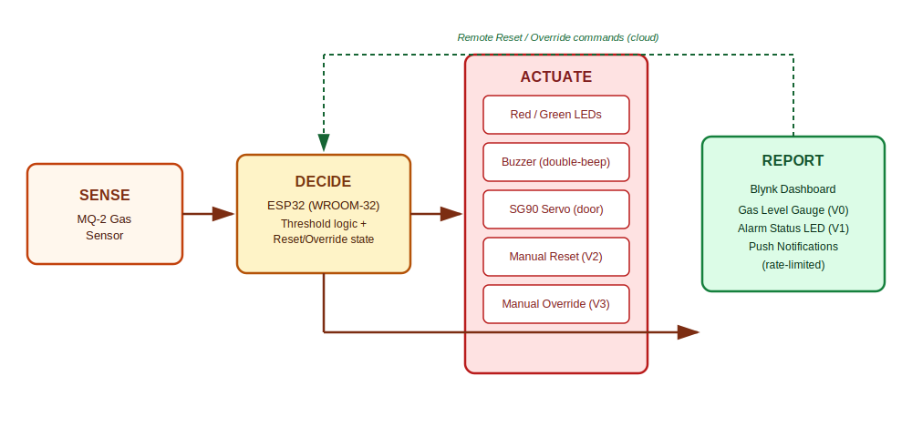
Figure 1: G.U.A.R.D system block diagram — sense, decide, actuate, report loop with cloud feedback.

4. Hardware Setup
The prototype was assembled on a breadboard for testing and demonstration. The ESP32 is wired to the MQ-2 gas sensor (analog output), the SG90 servo controlling the emergency door mechanism, an active buzzer, and status LEDs, all powered from a shared breadboard rail.
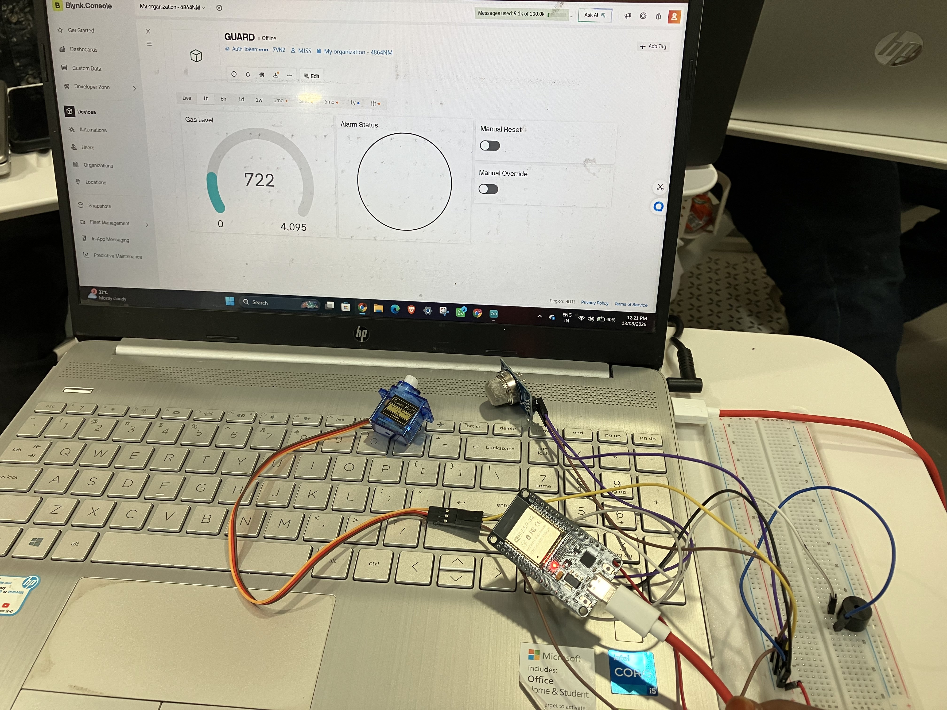
Figure 2: Breadboard prototype — ESP32, MQ-2 gas sensor, SG90 servo, buzzer, and supporting wiring.

Signal | ESP32 Pin | Notes
MQ-2 AOUT | GPIO 34 | ADC1 channel — safe to read while WiFi is active
Servo Signal | GPIO 18 | PWM control line for door mechanism
Buzzer + | GPIO 19 | Digital drive, non-blocking beep pattern
Red LED | GPIO 21 | Alarm indicator
Green LED | GPIO 22 | Safe-state indicator

4.1 Circuit Diagram
The schematic below shows each peripheral's connection point on the ESP32 and the shared power rail supplying the breadboard.
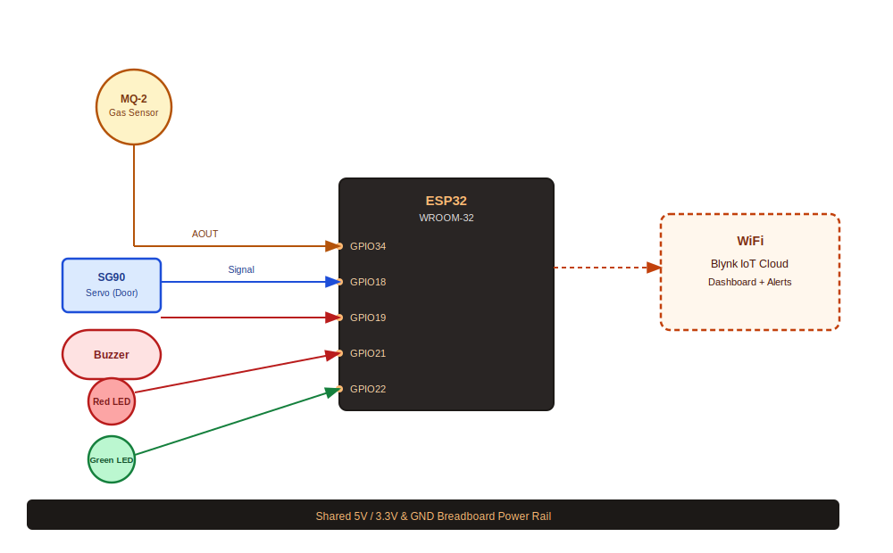
Figure 3: Circuit diagram — MQ-2, SG90 servo, buzzer, and status LEDs wired to the ESP32, with WiFi link to the Blynk cloud.

5. Firmware Logic

5.1 Sensor Warm-Up
The MQ-2 requires a heater warm-up period before its readings stabilize. On boot, the firmware withholds all alarm logic for 20 seconds (WARMUP_TIME), printing a warming-up status to serial, before beginning to trust and act on sensor readings.

5.2 Detection & Alarm State
Every 500 ms (READ_INTERVAL), the firmware reads the MQ-2 analog value and pushes it live to the Blynk gauge (V0). If the reading exceeds GAS_THRESHOLD (1800 on the 12-bit 0–4095 ADC scale) and the system is neither locked nor overridden, it enters the alarm state:
- Red LED ON, Green LED OFF.
- Buzzer begins a non-blocking double-beep pattern (150 ms on / 150 ms off, twice, then a pause) — driven independently via millis() so it never blocks the Blynk connection or sensor polling.
- Emergency door servo actuates open (0° → 90°).
- A rate-limited push notification (60-second cooldown) is sent via Blynk.logEvent, so a sustained leak doesn't flood the user with repeat alerts.

5.3 Manual Reset (V2) — Silence & Close, Stay Locked
Pressing Manual Reset on the dashboard silences the buzzer, closes the emergency door, and returns the LEDs to the safe state — but it also engages system Locked, which suppresses further automatic alarm triggers even if gas levels remain elevated. This is a deliberate safety choice: a one-tap reset should not let the system silently re-arm and re-trigger while the space may still be unsafe. The system stays in this locked, quiet state until the user explicitly issues a Manual Override.

5.4 Manual Override (V3) — Full System Reset
Manual Override performs a complete reset of the system's internal state: it clears the lock, clears any alert flag, silences the buzzer, closes the door, restores LEDs to safe, and resumes live automatic gas monitoring immediately. The toggle widget is programmatically switched back off after the action completes, so it behaves as a momentary reset action rather than a persistent switch.

5.5 State Summary
Trigger | Buzzer | Door | Monitoring
Gas > threshold | Double-beep ON | Opens | Active alarm
Manual Reset | OFF | Closes | Locked (no re-trigger)
Manual Override | OFF | Closes | Resumed (unlocked)

6. Blynk Dashboard
The dashboard mirrors the firmware's virtual pin map one-to-one: V0 drives the live Gas Level gauge, V1 drives the Alarm Status indicator, V2 is the Manual Reset switch, and V3 is the Manual Override switch.

6.1 Safe State
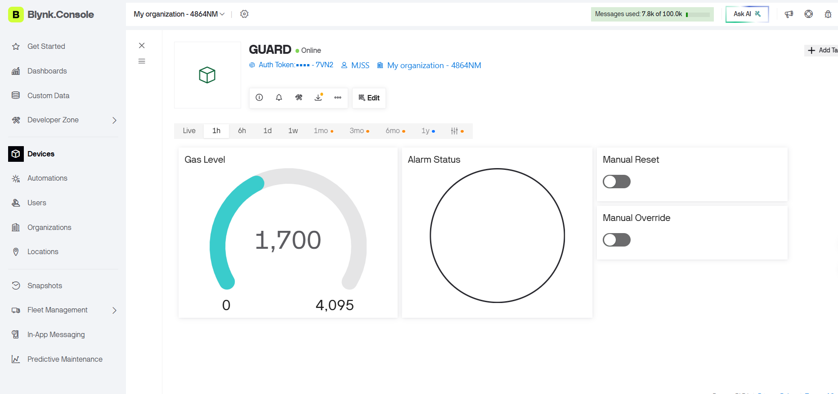
Figure 4: Dashboard in normal operation — gas level below threshold, Alarm Status LED unfilled, both controls off.

6.2 Alarm State
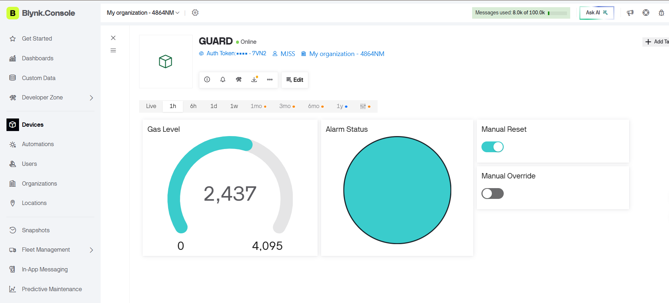
Figure 5: Dashboard during an active alarm — gas level above threshold , Alarm Status LED filled, Manual Reset engaged to silence and close the door.
Widget | Pin | Behaviour
Gas Level (Gauge) | V0 | Live MQ-2 reading, 0–4095 range, updated every 500 ms
Alarm Status (LED) | V1 | Fills when gas exceeds threshold; clears in safe state
Manual Reset (Switch) | V2 | Silences buzzer, closes door, locks out auto-alarm until override
Manual Override (Switch) | V3 | Full reset — clears lock, resumes automatic monitoring, self-resets to off

7. Testing & Results
The system was validated end-to-end using the breadboard prototype connected to the live Blynk dashboard shown above.
- Sensor warm-up: confirmed no false triggers during the 20-second MQ-2 heater warm-up window.
- Threshold crossing: verified alarm state (LEDs, buzzer double-beep, door open, dashboard Alarm Status fill, push alert) triggers correctly once gas readings pass 1800.
- Notification rate-limiting: confirmed repeat gas_alert events are suppressed within the 60-second cooldown window during a sustained leak.
- Manual Reset: confirmed buzzer silences, door closes, and the system correctly withholds re-triggering while gas remains above threshold.
- Manual Override: confirmed full state reset and immediate resumption of live automatic monitoring, with the toggle auto-returning to off.
- Dashboard sync: confirmed device online/offline status, gauge, and alarm indicator all reflect real-time firmware state (Figures 4 and 5).

8. Future Scope
- Field calibration of GAS_THRESHOLD against a certified reference gas source for the specific MQ-2 unit.
- Add a secondary sensor (e.g. MQ-135 or a temperature/smoke sensor) for cross-validated multi-hazard detection.
- Battery + charging circuit for backup operation during a power outage, which is often when gas leaks go undetected.
- Local buzzer/LED operation fallback if WiFi/Blynk connectivity drops, so the physical alarm never depends on the cloud link.
- Data logging and trend analysis on the Blynk dashboard for long-term air quality tracking.

9. Conclusion
G.U.A.R.D demonstrates a complete, low-cost embedded safety system that closes the loop between gas detection and physical emergency response — without requiring a human to be present. Its two-tier manual control design (Reset vs. Override) reflects a deliberate safety-first approach: a quick reset should quiet the alarm, but only an explicit override should fully re-arm the system. Combined with real-time cloud visibility through Blynk, the project shows a practical, extensible pattern for IoT-based hazard monitoring suitable for homes, labs, or industrial small spaces.

